**Name: Muhammad Ahmad Raza Qadri.**

**Intern ID: TN/IN02/PY/013**

**Task no: 01.**

**Question:**

1. **Install Python & print version.**
2. **Run hello script printing your name.**

**Code 1:**

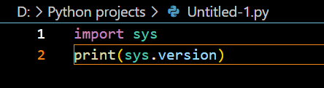

**Output:**

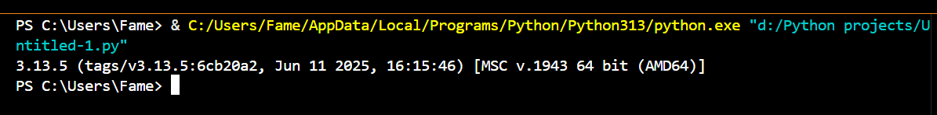

**Code 2:**

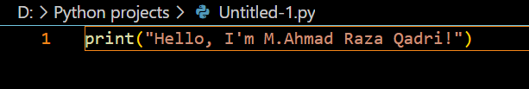

**Output:**

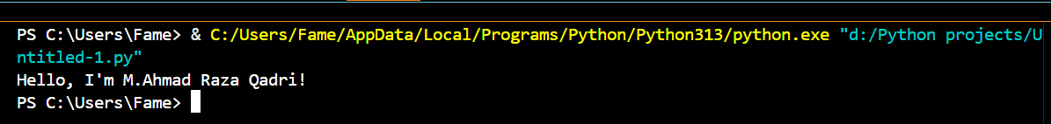

**Task no: 02.**

**Question:**

1. **Fix badly-indented code.**
2. **Add comments explaining each step.**

**Badly-Indented code with output:**

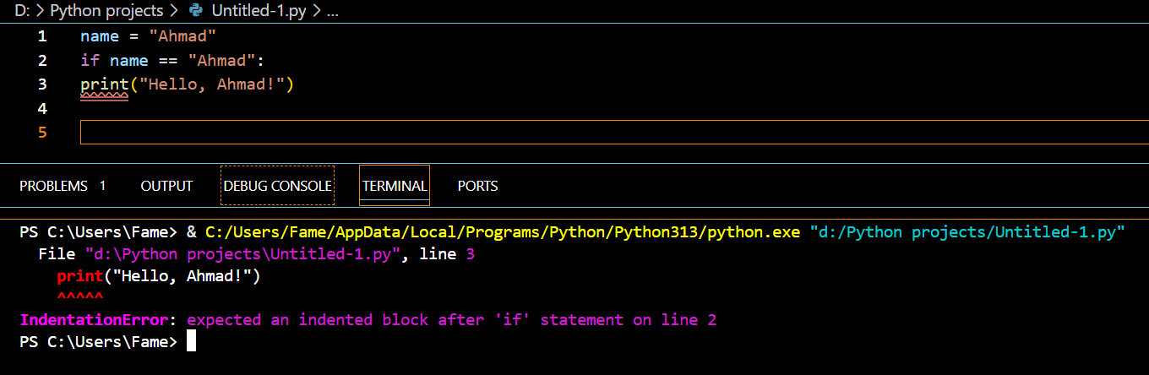

**Fixed Badly-Indented code with output:**

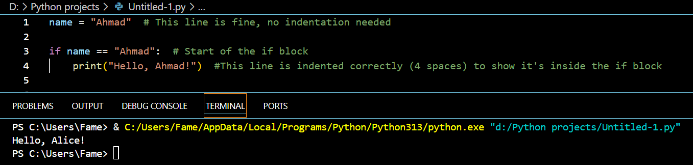

**Task no: 03.**

**Question:**

**1. Collect user profile & print typed summary.**

**2. Swap two variables without temp var.**

**Code 01 with Output:**

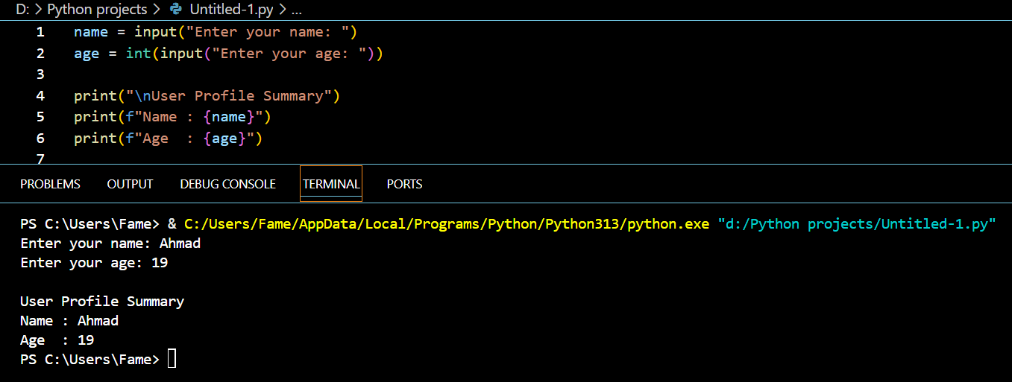

**Code 02 with Output:**

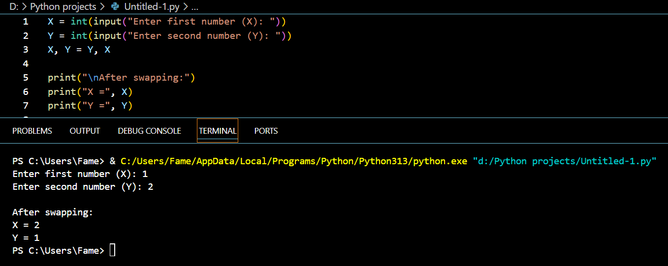

**Task no: 04.**

**Question:**

**1. Read three numbers; output avg.**

**2. Convert minutes to hours + minutes.**

**Code 01 with Output:**

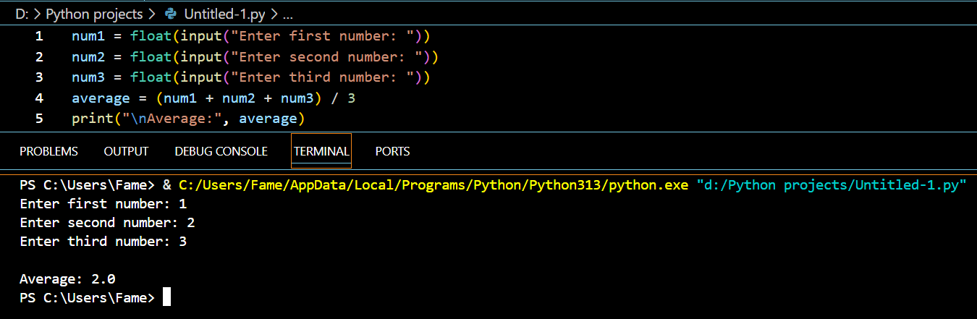

**Code 02 with Output:**

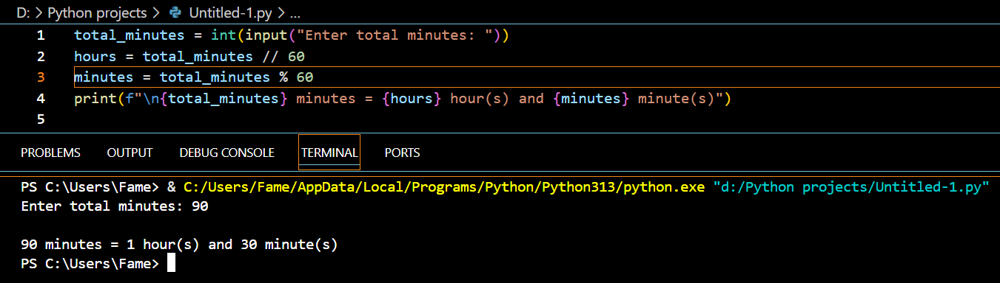

**Task no: 05.**

**Question:**

**1. BMI calc from user input.**

**2. Simple interest calc.**

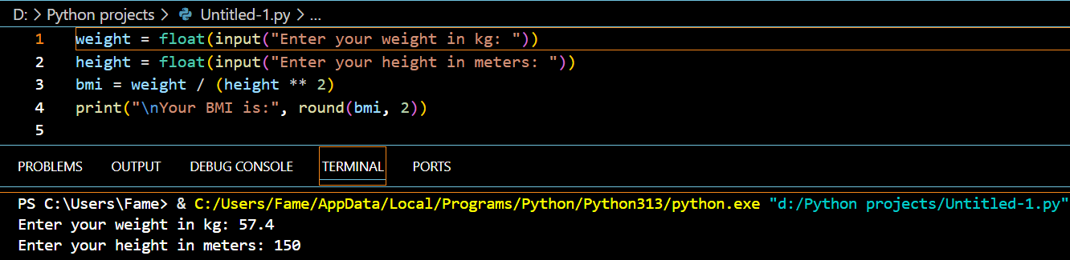**Code 01 with Output:**

**Code 02 with Output:**

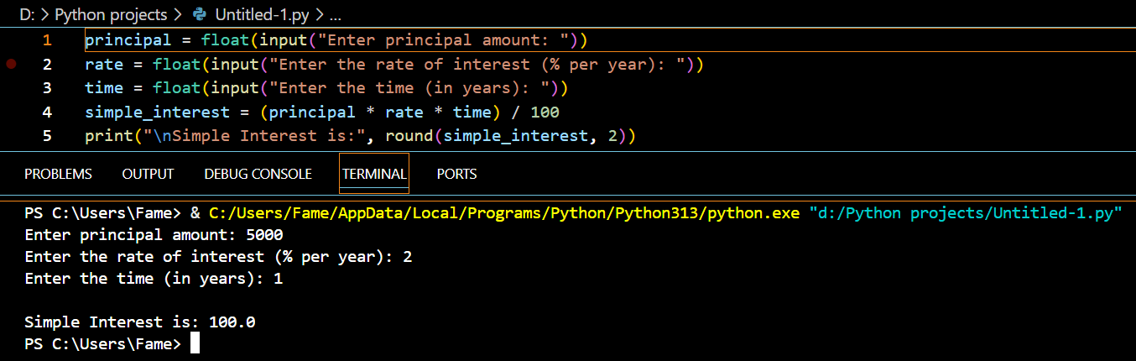

**Task no: 06.**

**Question:**

**1. Username builder from full name.**

**2. Vowel/consonant counter.**

**Code 01 with Output:**

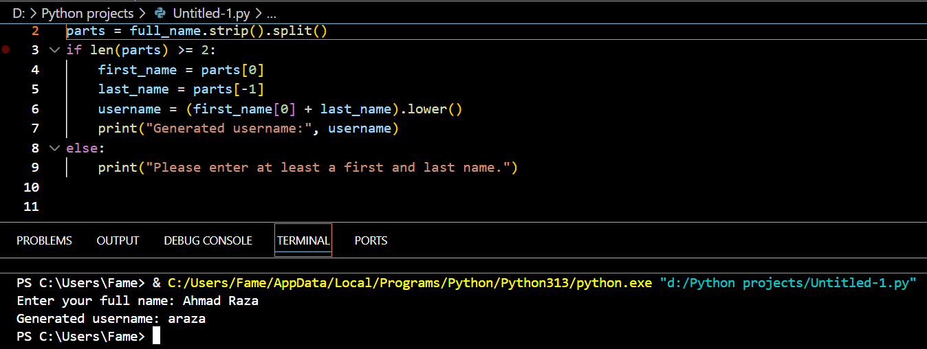

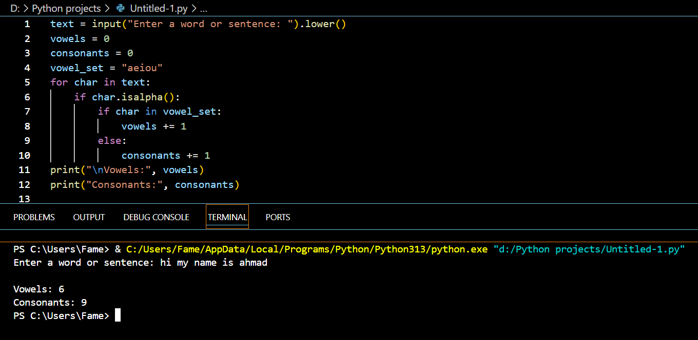**Code 02 with Output:**

**Task no: 07.**

**Question:**

**1. Grade calculator.**

**2. Password strength classifier.**

**Code 01 with Output:**

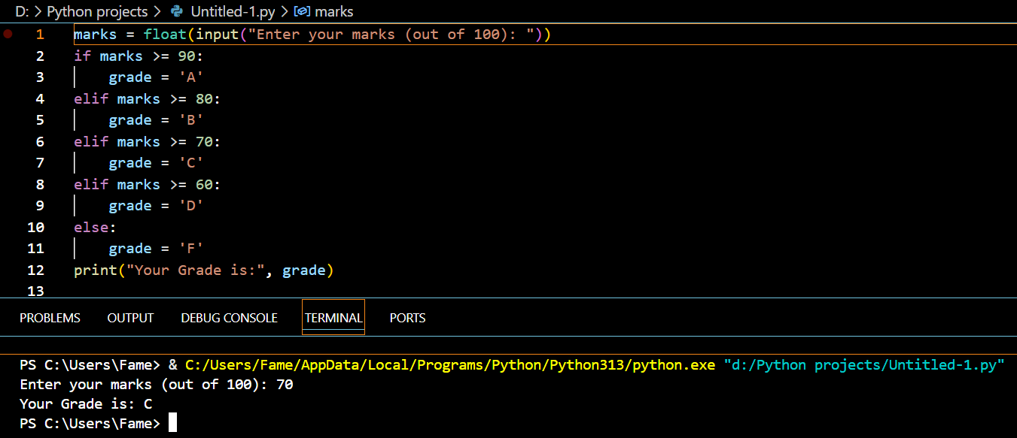

**Code 02 with Output:**

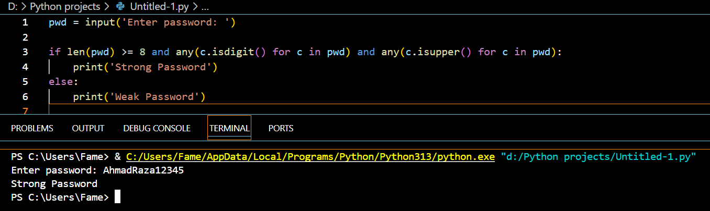

**Task no: 08.**

**Question:**

**1. Multiplication table.**

**2. Sum numbers divisible by 3.**

**Code 01 with Output:**

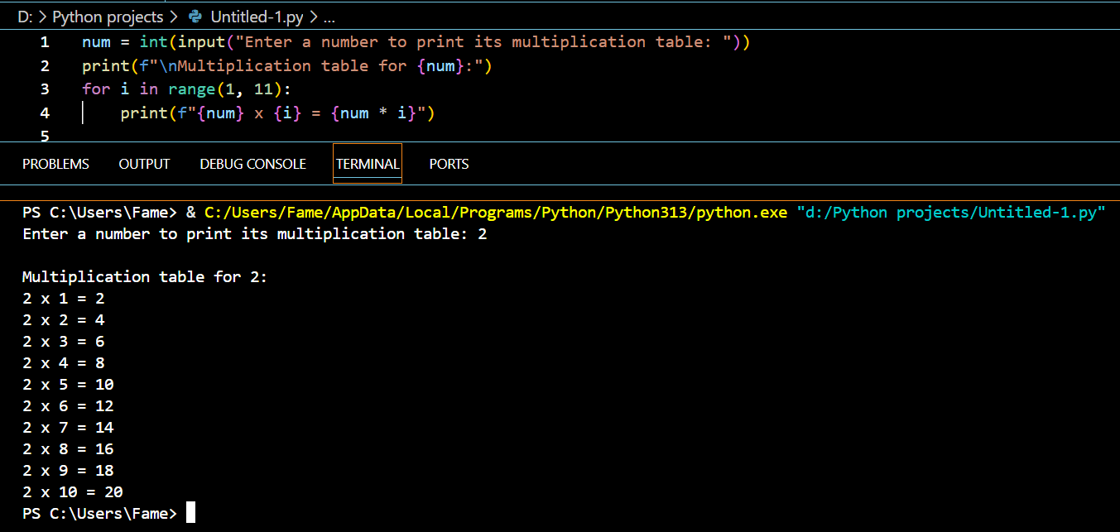

**Code 02 with Output:**

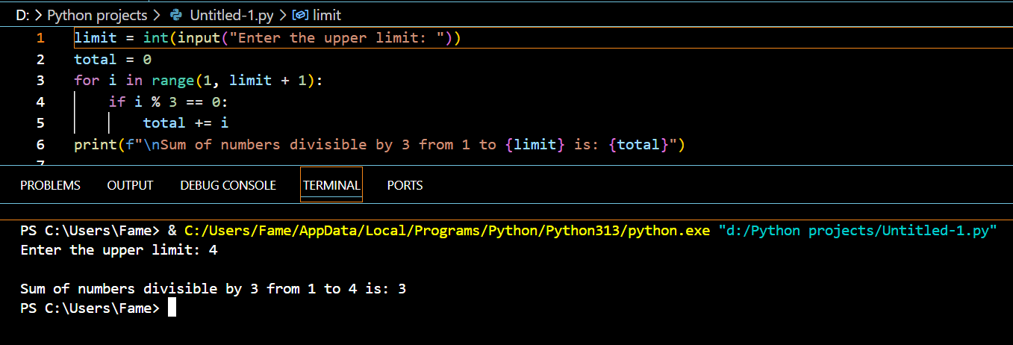

**Task no: 09.**

**Question:**

**CLI Unit Converter: length, weight, temperature menus + loops & conditionals**

**Code:**

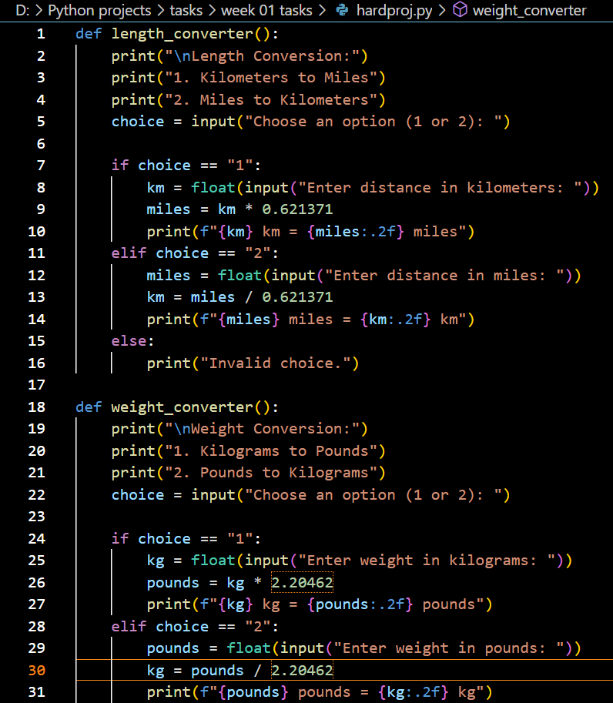

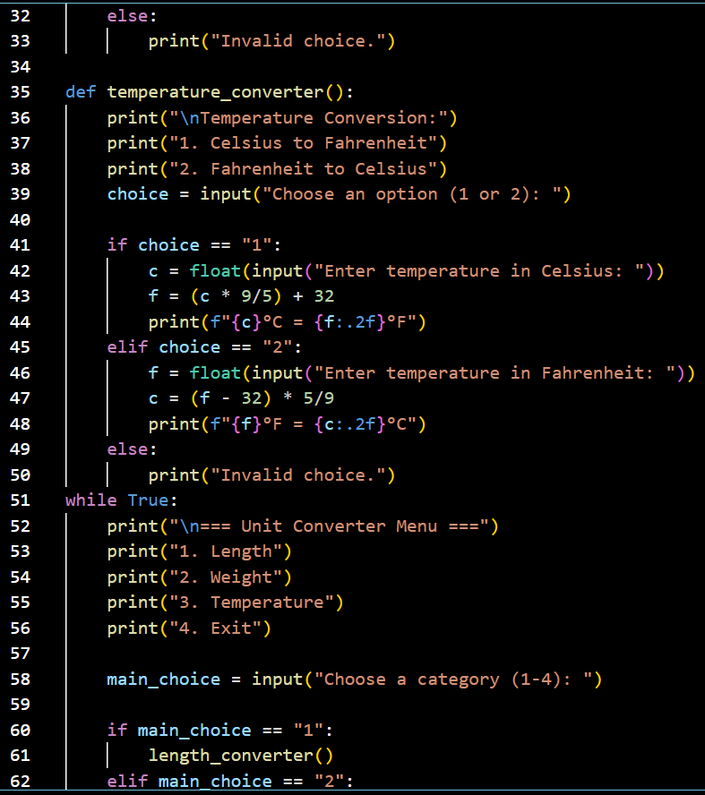

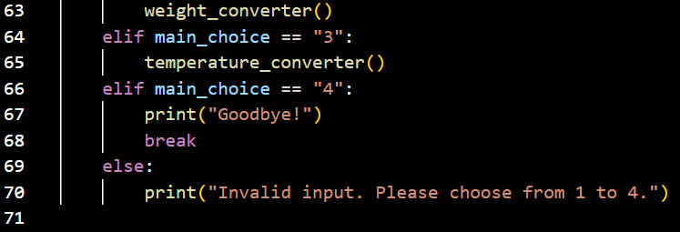

Output

